# Tutorial Android Application Development

1. What is Android and the latest version of Android?

🡪 Android is a mobile operating system based on a modified version of the Linux kernel and other open-source software, designed primarily for touchscreen mobile devices such as smartphones and tablets. The latest version of Android OS is 12, released in October 2021.

2. Which Operating System Android is based on?

🡪 Android OS is a Linux-based mobile operating system

3. What is role of package name? What care should be taken while naming a package?

🡪 The package name of an Android app uniquely identifies your app on the device, in Google Play Store, and in supported third-party Android stores.

The name should be unique.

The name may contain uppercase or lowercase letters ('A' through 'Z'), numbers, underscores ('_') and period (‘.’).

Individual package name parts may only start with alphabetic letters. (ex. com.2yagnik is invalid package name)

At least single period (‘.’) required in package name.

Note : To avoid conflicts with other developers, you should use Internet domain ownership as the basis for your package names (in reverse). For example, applications published by Google start with com.google. But there is no rule that you have to start it with “com”

4. What is the meaning of Minimum SDK option while creating a new Project?

🡪 The min sdk version is the earliest release of the Android SDK that your application can run on. Usually this is because of a problem with the earlier APIs, lacking functionality, or some other behavioural issue. The target sdk version is the version your application was targeted to run on. Based on this, developer can see the number of people (in percentage) on the glob who can use the application on their device.

5. Explain View and ViewGroups with a diagram.

🡪 A View usually draws something the user can see and interact with. Whereas a ViewGroup is an invisible container that defines the layout structure for View and other ViewGroup objects

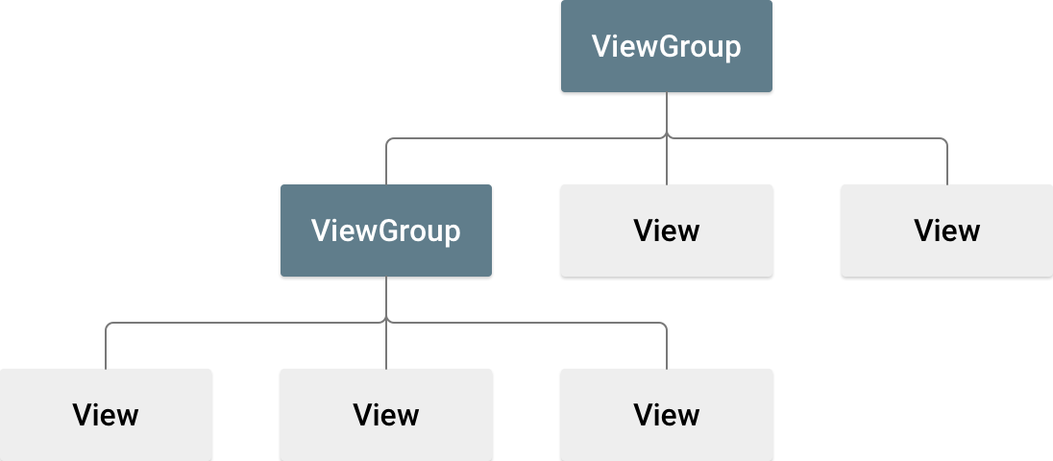

Read more from here: <https://www.geeksforgeeks.org/difference-between-view-and-viewgroup-in-android/>

6. Write down sample code to create following structure.

🡪 Tushar, hellppp… (code will be given in subsequent part of this document)

7. What are Layouts for? List down different layouts (atleast 5). Differentiate between Linear Layout and Relative Layout.

🡪 A layout defines the structure for a user interface in your app, such as in an activity. All elements in the layout are built using a hierarchy of View and ViewGroup objects.

Link: <https://developer.android.com/develop/ui/views/layout/declaring-layout>

🡪 List:

1. Android Linear Layout
2. Android Relative Layout
3. Android Constraint Layout
4. Android Frame Layout
5. Android Table Layout
6. Android Web View
7. Android ListView
8. Android Grid View

Link: <https://www.geeksforgeeks.org/android-ui-layouts/>

🡪 LinearLayout: LinearLayout is a type of view group which is responsible for holding views in it either horizontally or vertically. It is a type of Layout where one can arrange groups either Horizontally or Vertically.

RelativeLayout: RelativeLayout is a layout in which we can arrange views/widgets according to the position of other view/widgets. It is independent of horizontal and vertical view and we can arrange it according to one’s satisfaction.

|  |  |
| --- | --- |
| LinearLayout | RelativeLayout |
| We can adjust views and widgets linearly i.e. Horizontally and vertically. | We can adjust views and widgets according to one’s satisfaction. |
| **layout_weight** attribute in the linear layout is used to specify the equal or specific size to the particular widget and view by using the following attribute.  **android:layout_weight = ‘0’**  Here Weight is specified as 0 in order to give equal size or space to each view or widget. | Various attributes like: **layout_toRightOf, layout_toLeftOf, layout_below, layout_alignParentTop, layout_top, layout_alignParentLeft, layout_alignParentRight** are used to specify the position of each view and widget. |
| It is  useful when we arrange views in a linear fashion | It is useful when we arrange views in a relative fashion. |
| **Syntax:**  <LinearLayout>  <!–Views, widgets–>  </LinearLayout> | **Syntax:**  <RelativeLayout>  <!–Views, Widgets–>  </RelativeLayout> |
| **Example:** In various Apps, LinearLayout is mainly applicable in the SignUp screen where Name, Email, Phone Number, Submit, etc. are arranged in a linear fashion. | **Example:** In Google Play Store, when we open the app, the games, books, movies, and App’s sections all are arranges in Relative Layout Fashion. |
| LinearLayout is less used as compared to RelativeLayout. | RelativeLayout is used more in applications. |
| We can use LinearLayout inside RelativeLayout. | We can also use RelativeLayout as a Child of LinearLayout. |

Link: <https://www.geeksforgeeks.org/difference-between-linearlayout-and-relativelayout-in-android/>

8. How important is Constraint Layout. State its benefits.

🡪 It helps to improve the UI performance over other layouts. With the help of ConstraintLayout, we can control the group of widgets through a single line of code. With the help of ConstraintLayout, we can easily add animations to the UI components which we used in our app.

9. Describe the Anroid architecture in detail.

🡪 Read from here: <https://www.geeksforgeeks.org/android-architecture/>

(Write whatever you can remember from this page. Keywords:

* open-source Linux Kernel
* collection of number of C/C++ libraries
* Applications
* Application Framework
* Android Runtime
* Platform Libraries

)

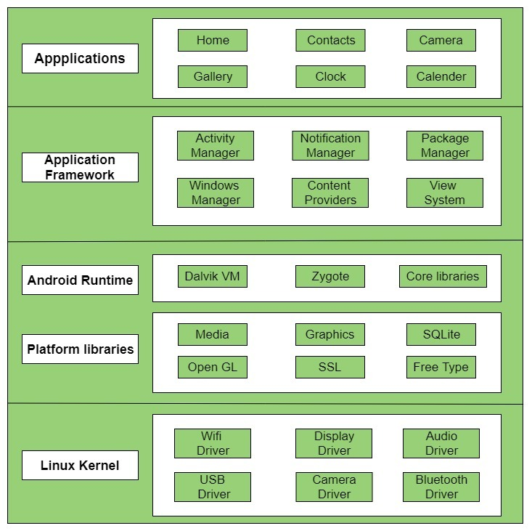

10. What is the role of Emulator?

🡪 The Android Emulator simulates Android devices on your computer so that you can test your application on a variety of devices and Android API levels without needing to have each physical device.

11. What’s Activity in Android?

🡪 Activity class is one of the very important parts of the Android Component. Any app, don’t matter how small it is (in terms of code and scalability), has at least one Activity class. Unlike most programming languages, in which the main() method is the entry point for that program or application to start its execution, the android operating system initiates the code in an Activity instance by invoking specific callback methods that correspond to specific stages of its Lifecycle. So it can be said that An activity is the entry point for interacting with the user.

Read from here: <https://www.geeksforgeeks.org/introduction-to-activities-in-android/>

12. What are the components of the Android Application? Explain each of them in  
brief with an example.  
a) Activities  
b) Services  
c) Content Providers  
d) Broadcast Receiver  
e) Intents

🡪

* Activities: The activity serves as the entry point for an app's interaction with the user. It provides the window in which the app draws its UI.
  + E.g., Home screen of an application is one activity, through which user can interact. From here, user can navigate to another activity by clicking a button or by giving an appropriate input. Everything user can see on the screen while accessing the application is indeed an activity.
  + We must define all the activities in our manifest file

<activity

android:name=".MainActivity"

android:exported="true">

<intent-filter>

<action android:name="android.intent.action.MAIN" />

<category android:name="android.intent.category.LAUNCHER" />

</intent-filter>

</activity>

* Services: A Service is an application component that can perform long-running operations in the background. It does not provide a user interface. Once started, a service might continue running for some time, even after the user switches to another application. Additionally, a component can bind to a service to interact with it and even perform interprocess communication (IPC).
* Content Providers: Content providers can help an application manage access to data stored by itself, stored by other apps, and provide a way to share data with other apps. They encapsulate the data, and provide mechanisms for defining data security. Content providers are the standard interface that connects data in one process with code running in another process.
  + E.g.,
* Broadcast Receiver: Broadcast in android is the system-wide events that can occur when the device starts, when a message is received on the device or when incoming calls are received, or when a device goes to airplane mode, etc. Broadcast Receivers are used to respond to these system-wide events. Broadcast Receivers allow us to register for the system and application events, and when that event happens, then the register receivers get notified.
  + There are mainly two types of Broadcast Receivers:
    - Static Broadcast Receivers: These types of Receivers are declared in the manifest file and works even if the app is closed.
    - Dynamic Broadcast Receivers: These types of receivers work only if the app is active or minimized.
  + E.g.,
* Intents:

13. What is the AndroidManifest.xml? This file resides in which folder?  
14. Write a statement to access permission for Camera in AndroidManifest.xml file.  
15. Ravina created two Activities titled as Mainactivity and SecondActivity. She  
would like to launch an application using SecondActivity. What steps she shall  
follow?  
16. Which files do exist in values folder when a new Android Project is created using  
Android Studio?  
17. Describe the usage of Strings.xml file giving one example.  
18. Describe the usage of colors.xml file giving one example.  
19. Describe the usage of dimens.xml file giving one example.  
20.Describe the usage of styles.xml file giving one example.  
21. Explain Activity Life Cycle with diagram.  
22.Differentiate between:  
a) onCreate() and onStart() Methods  
b) onPause() and onRestart() Methods  
23. Give one example of using Log Class for debugging.  
24.Explain following attributes of Linear Layout.  
a) Gravity  
b) Orientation  
25. What is padding used for?  
26. Differentiate between Gravity and Layout Gravity.  
27. Which attribute is used to display the visible text on Button?  
28.Can an image be placed on Button? Write down the steps.  
29.Can text on Button be right aligned? If yes, which attribute can be used and  
how?  
30.What is id attribute for? Write down its usage giving an example.  
31. Write down the code for the following:  
• Two buttons and one text view on the screen. One button has text titled” Hello”  
and second includes “Namaste”. Clicking on each button makes textview filled  
with Hello or Hi depending on the button clicked. Use OnClick attribute of  
button.  
32. What is hint attribute used for in EditText View?  
33. Can you comment a code while creating an Android App Development? What are  
the ways? Explain one example for each file, activity_main.xml and  
Mainactivity.java both.  
34. Showcase the usage of Method Overriding used while creating an app.  
35. What are sp, dp used for? Explain each of them giving an example.  
36. What is the way to change color of Button?  
37. Write down the syntax and usage of findViewbyId method.  
38.What is the Dalvik Virtual Machine?  
39. What are the differences between Dalvik and ART?  
40.What are APK files? Write down the steps to be taken for uploading App on play  
Store?